The optimized net present value over the 10-years project time is 1697.6*108$. Major results are listed in the following chart. Excerpts of run report and commentary to corresponding parts are also listed below, for detail run report please check the other file.

|  |  |  |  |  |  |
| --- | --- | --- | --- | --- | --- |
|  | Chemical 1 purchased (kton) | Chemical 2 purchased (kton) | Chemical 3 produced by process 2 (kton) | Chemical 3 produced by  process 3 (kton) | Total chemical 3 (kton) |
| Period 1 | 6 | 20 | 20.824 |  | 20.824 |
| Period 2 | 7.5 | 25.5 |  | 30.721 | 30.721 |
| Period 3 | 8.6 | 30 |  | 35.95 | 35.95 |
|  | Expansion Strategy | | Size of expansion (kton) | Investment ($) | NPV ($) |
| Period 1 | Expand process 1 | | 7.748 | 9.5692*106 | 1.6976*108 |
| Period 2 | Expand process 3 | | 35.95 | 2.0912*107 |
| Period 3 |  | |  |  |

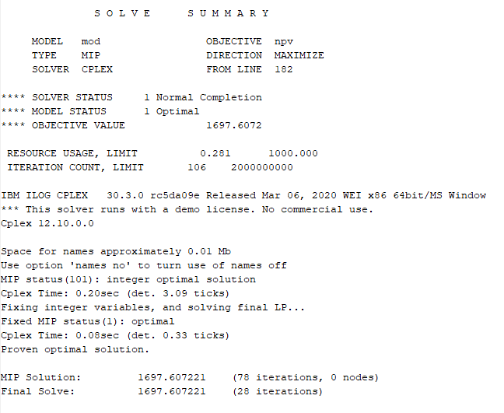

y is a binary variable, with value either 1 or 0. In this context, “1” means to build a process. Process 1 is invested at the start of the project, while process 3 is invested at year2.

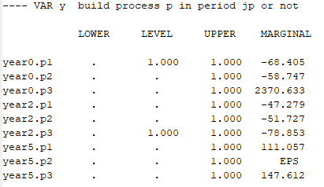

The amount of capacity expanded.

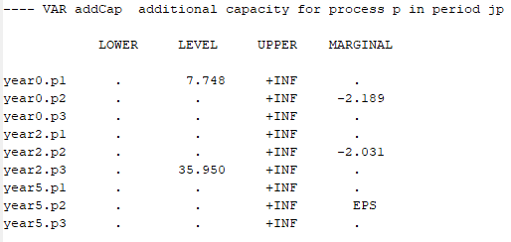

Though p1 is expanded to 7.748kton at year0, it’s not used to full capacity until year6 (due to lower availability for chemical1 in early periods). And after p3 is invested on year2, p2 is no longer used. Note that p2 already has a capability of 50 kton/yr in the beginning.

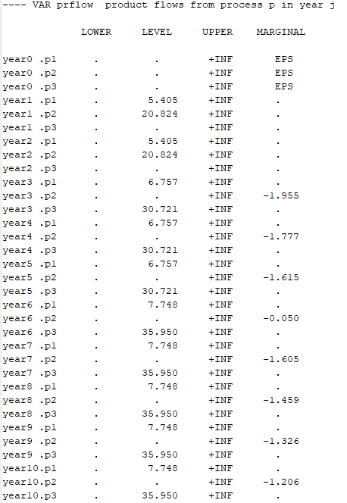

Chemical1 and chemical2 are both purchased every year, meaning chemical2 is supplied by both direct purchase and manufacturing in line. Chemical3 sales amount is always lower than upper limit while chemical1 and 2 purchase amount are always at upper limit, indicating insufficient supply of raw materials.

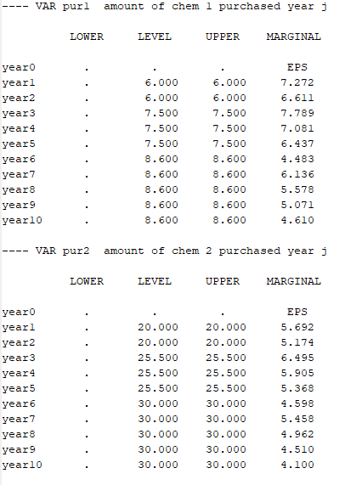

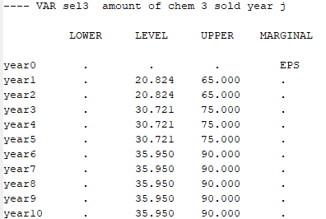

A summary on economical results (invest amount, sales amount, operating expenses, purchasing fee, working capital, taxable income, depreciation, net present value).

